Pokhara University

Level: Bachelor | Semester – Spring | Year : 2007
Programme: BE |  | Full Marks: 100
Course: Chemistry |  | Time : 3hrs.

Candidates are required to give their answers in their own words as far as practicable.
The figures in the margin indicate full marks.

Attempt all the questions.

 | - Explain hydrogen spectra on the basis of Bohr’s theory. Calculate the wavelength of electron of H-atom when electron jumps from 3rd orbit to the ground state energy level. (Rydberg’s constant, R = 1.097373 × 10⁷ m⁻¹).  - State the uncertainty principle and explain why we can not predict precise paths or orbits for very small particles such as electron. Calculate the de-Broglie’s wave length of an electron mooing at a speed of 3 × 10⁷ m/s (Given: h = 6.62 × 10⁻³⁴ Js, mass of electron = 9.1091 × 10⁻³¹ Kg). | 5+3  4+3
 | - Define and derive Ostwald’s dilution law for the ionization of a weak electrolyte.  - State and explain the principle of Standard Hydrogen electrode. Calculate the emf of following cell at 25⁰C  Zn/zn⁺⁺ (0.01M)//Ag⁺ (0.1M)/Ag  The standard potentials of Silver and Zinc half cell are + 0.80V and -0.76V respectively. Given; R = 8.314 JK⁻¹mol⁻¹ , F = 96500 C | 7  8
 | - What is electron affinity? What are the factors that affect the value of electron affinity?  - Describe why P-block elements are powerful oxidizing agent.  - What are transition elements? The complex formation is the main characteristics of transition elements. Explain. | 7  3  5
 | - Explain the structure of water on the basis of Hybridization.  - Explain the following statements.  - Water has much higher boiling point than Hydrogen sulphide.  - Second ionization energy is higher than first ionization energy.  - LiCl is covalent but NaCl is ionic. | 6  3×3
 | - Write the IUPAC name of following organic compounds:  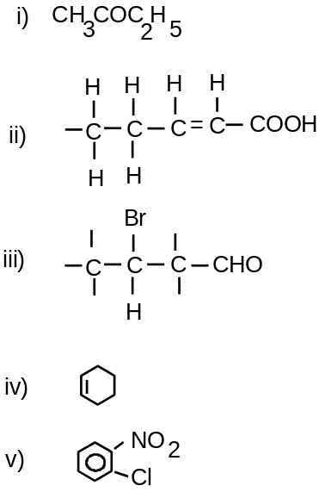 | 5
 | - What is Carbocation? Explain the types and stabilities of Carbocations.  - Explain enantiomerism with suitable example. | 5  5
 | - What is electrophilic substitution reaction? Explain the mechanism of SN/ and E/ reaction.  - Differentiate between thermosetting and thermoplastic polymers. | 9  6
 | Write short notes on (Any Two):  - Green House effect  - COD  - Quantum numbers  - Electrochemical series | 2×5

